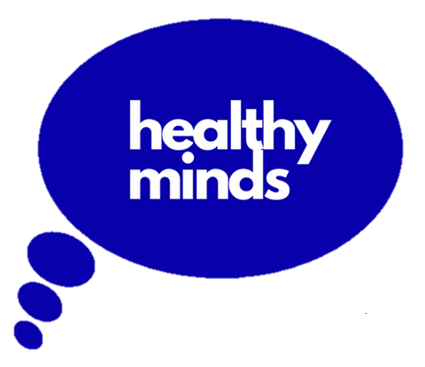
Public note - board meeting 24th February 2021

Calderdale Wellbeing’s (Healthy Minds) board of trustees is responsible, as a whole, for ensuring that Healthy Minds delivers its aims and objectives. The trustees are all volunteers, and are confirmed at Healthy Minds’ Annual General Meeting. The trustees bring a variety of skills to the board. The board of trustees meets six or seven times a year.
Whilst the board does at times need to consider sensitive issues, relating to finance, services or staff, the majority of its discussions are not necessarilyconfidential. A summary note is provided to staff after each board meeting. The trustees would like to try sharing a note more widely. This note will be approved at the next board meeting, and published on Healthy Minds’ website.
The Healthy Minds board of trustees met via videoconference on Wednesday evening, 24th February 2021, with nine trustees present. Healthy Minds’ Chief Officer, Jonny Richardson-Glenn, its two senior operational managers, and a member of administrative staff, were also in attendance.
The Chief Officer provides an operational update to each meeting of the board. This covers each service, with a focus on new developments and risks. The board noted the staff, volunteer, service and funding developments for Marketing and Fundraising, Safespace, Peer Support in Crisis, Money in Mind and Roshani. We discussed issues in relation to the continued funding for services in Todmorden and Hebden. We were glad to confirm continued funding of Todmorden and Hebden services until end June, whilst we continue to explore longer-term funding. We look forward to the outcome of the regional community mental health transformation programme and funding application, into which the Chief Officer continues to contribute local and regional voluntary and community sector leadership.
Trustees were delighted to receive the brilliant news that Healthy Minds has been awarded Level 2 Quality 4 Health – the highest possible level. This is a terrific achievement and recognition that Healthy Minds works to a high-quality standard. There will be a formal awarding of the certificate, at which time we’ll publicise this achievement. Those involved will know this has been a long and arduous process. Every single standard in the assessment was fully met. Thanks to all, especially Di Darby for coordinating the assessment throughout. The full assessment includes a few recommendations for future actions which we reviewed, and to which we will respond at the next board meeting.
The board received an outline of a new Funding Strategy and look forward to receiving the final proposal at our next board meeting. We shall continue to be led by need: we seek funding that supports work to address identified needs that fit with the strategic aims and objectives of Healthy Minds. We want to spread risk by not being over-reliant on any particular funder. We will do so in an admittedly more challenging financial landscape. We do so also, however, in a landscape where the value of our services is also greatly increased, with higher confidence, trust and profile than ever before. We are determined that the culture of Healthy Minds will lead our Funding Strategy. Each service will articulate evidence of need, how the service addresses need, its impact, and resource requirements. We will establish more robust impact measurement and reporting to build the evidence base for Healthy Minds as a safe and effective provider.
The board also considered other matters, including: approval of the Forward Plan, 2021/22; agreement for the board to meet, in addition to its planned business meetings, for an open, “no agenda”, meeting approval of minimum reserves and draft budget for 2021/22; approval of amendment to the Reserves Policy, part of the Finance Policy; approval of Financial Controls, for external review in 2021/22.
We finished by noting that the Chief Officer and senior operational managers have met to agree a timetable for emerging from the restrictions imposed for controlling COVID-19. We have done a fantastic job during this past year, although not without cost. Emerging from restrictions may give rise to some anxiety, as well as to hopeful anticipation – it does for me and, I think, for some other trustees. We have a great record for managing through change with sensitivity, imagination and courage. I look forward, despite any anxieties, in emerging from current restrictions, to continue to deliver high quality services, in line with our aims.
Paul Hunt
Chair of Trustees
Published, April 2021

